Ontos Cosmos User Guide

Ontology Development Platform
Version 1.1 (Enhanced)
January 2025
__________________________________________________

Table of Contents
- Introduction
- 1.1 Platform Architecture
- 1.2 User Roles
- Getting Started
- Account Management
- Dashboard Overview
- Project Management
- Working with Ontologies
- Document Processing
- 7.1 Processing Pipeline Details
- Leximap Workflow
- Blackkey Ontology Management
- Knowledge Graph Visualization
- Queries & SPARQL
- Reports & Validation
- Workspaces
- Settings & Preferences
- Troubleshooting
__________________________________________________

1. Introduction

What is Ontos Cosmos?
Ontos Cosmos is an AI-powered ontology development platform that transforms documents into professional-grade semantic ontologies with interactive knowledge graph visualization. The platform supports:
- Document Processing: Upload PDF, DOCX, TXT, and other formats for automated analysis
- Ontology Generation: AI-driven extraction of entities, relationships, and semantic triples
- Knowledge Graph Visualization: Interactive D3.js-powered graphs with multiple layout options
- Standards Compliance: BFO (Basic Formal Ontology) and CCO (Common Core Ontologies) alignment
- Multi-Format Export: OWL, RDF/TTL, JSON-LD, GraphML, and more

Key Features
Feature | Description
AI-Powered Processing | Leverages Claude AI for intelligent entity extraction
Multi-Tenant Architecture | Secure project isolation for teams and organizations
Real-Time Collaboration | Work together on ontology development
Visual Ontology Builder | Drag-and-drop interface for manual refinement
Quality Validation | Automated checks for ontology consistency and completeness

2. Platform Architecture
Ontos Cosmos is built on a modern microservices architecture designed for scalability, security, and real-time collaboration.

Core Components
Component | Description
Frontend | React 18 + Vite SPA with widget-based workspace system
Gateway Service | WebSocket gateway bridging frontend to backend services
Data Service | Multi-tenant CRUD operations for projects, ontologies, workspaces
Ingest Service | Document upload and file processing
Parser Service | Text extraction and NER processing
Ontology Orchestrator | AI-driven pipeline for taxonomy generation

Multi-Tenant Architecture
Ontos Cosmos supports multiple organizations (tenants) with complete data isolation:
- Each tenant has isolated projects, ontologies, and workspaces
- Data never crosses tenant boundaries
- Configurable access permissions per tenant
__________________________________________________

3. User Roles
Ontos Cosmos supports different user roles with specific capabilities:
Role | Capabilities
Data Engineer | Document ingestion and annotation, data source configuration, taxonomy creation and editing, bulk data operations, export management
Ontologist | Ontology creation and editing, taxonomy to ontology conversion, version control and release management, quality validation, SHACL constraint authoring
Analyst | Knowledge graph exploration, SPARQL and natural language queries, relationship analysis, report generation, data visualization
Commander | Mission dashboard viewing, status report generation, KPI monitoring, read-only access to ontologies
Admin | System configuration, user management, model registry management, API key administration, audit log review, health monitoring
__________________________________________________

4. Getting Started

System Requirements
Supported Browsers:
- Google Chrome (recommended)
- Mozilla Firefox
- Microsoft Edge
- Safari
Screen Resolution:
- Minimum: 1280 x 720
- Recommended: 1920 x 1080 or higher

Accessing Ontos Cosmos
- Open your web browser
- Navigate to your Ontos Cosmos URL:
- Cloud: https://demo.ontos-cosmos.ai/
- On-Premise: Your organization's configured URL
- You will see the login screen
__________________________________________________

5. Account Management

Creating a New Account
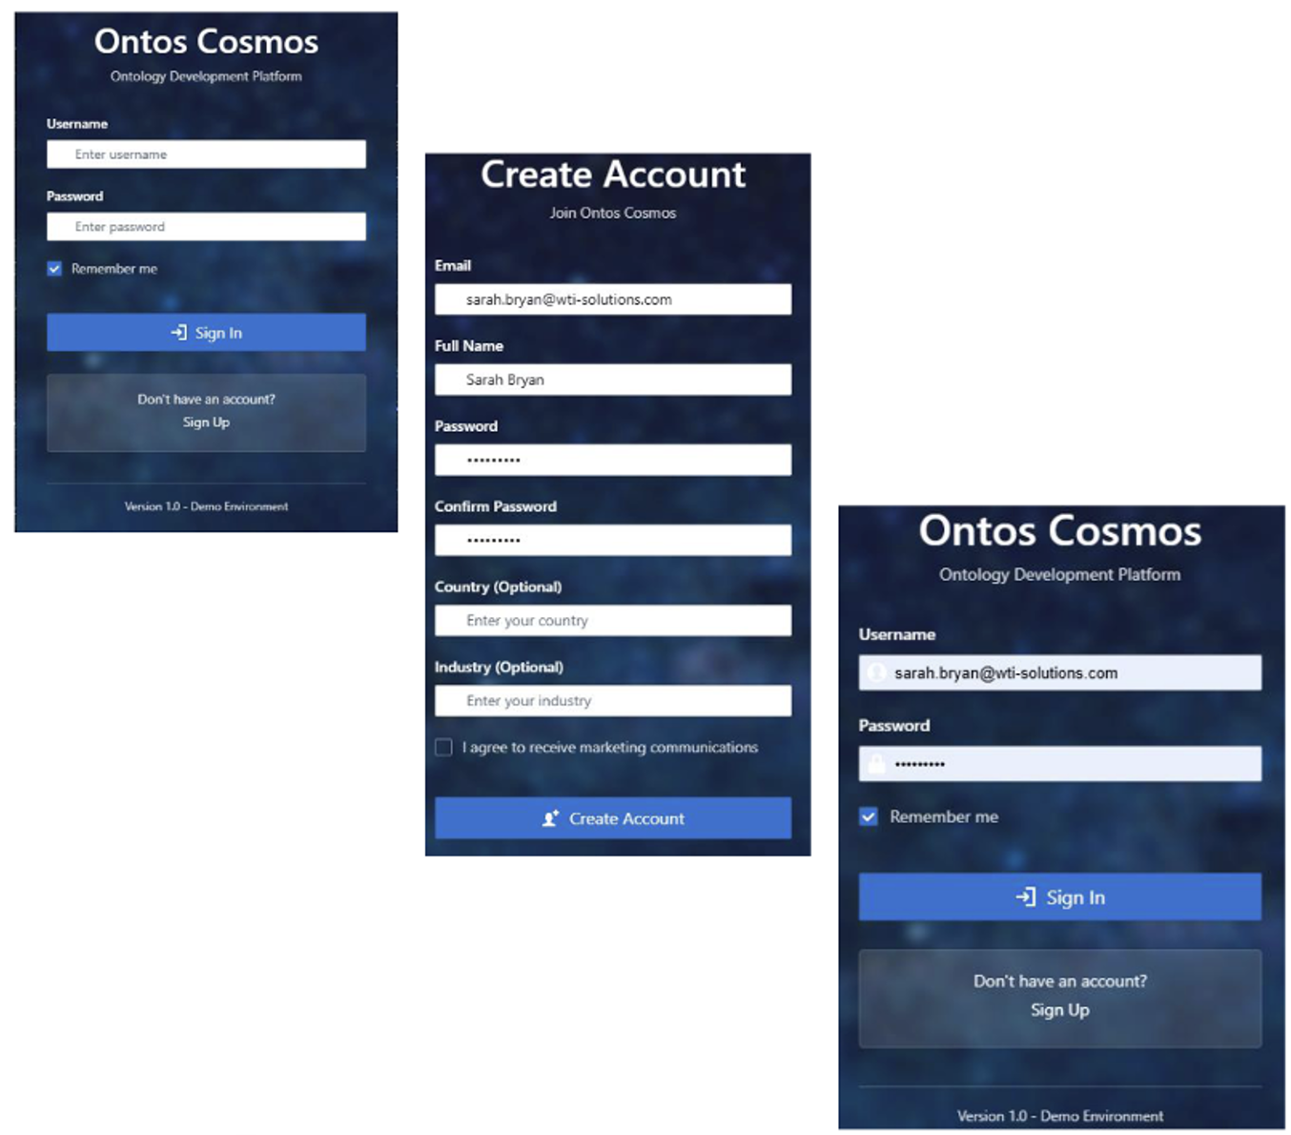

Figure 3.1: Account creation process showing login screen, sign-up form, and confirmation
Steps to create an account:
- Navigate to the Ontos Cosmos login page
- Click "Sign Up" below the Sign In button
- Complete the registration form:
Field | Required | Description
Email | Yes | Your email address (used as username)
Full Name | Yes | Your display name
Password | Yes | Minimum 8 characters recommended
Confirm Password | Yes | Must match password
Country | No | Your location (optional)
Industry | No | Your industry sector (optional)
Marketing | No | Opt-in for communications
- Click "Create Account"
- You will be redirected to the login screen

Signing In
The login screen provides a clean, simple interface:
- Enter your Username (email address)
- Enter your Password
- Optionally check "Remember me" to stay logged in
- Click "Sign In"
Note: The version number is displayed at the bottom of the login screen (e.g., "Version 1.0 - Demo Environment")

User Profile Menu
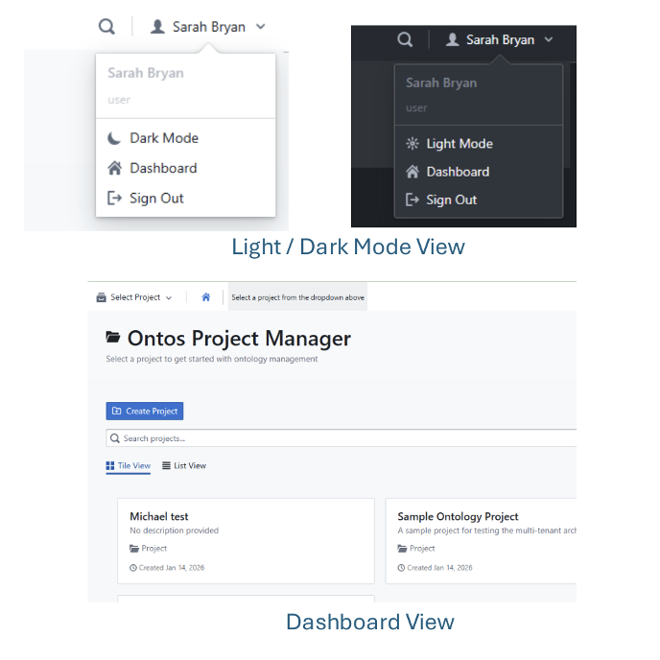
Figure 3.3: User profile dropdown showing theme options and navigation
Access your profile by clicking your name in the top-right corner. The dropdown menu provides:
Option | Description
User Name | Displays your account name and role (e.g., "Sarah Bryan - user")
Dark Mode / Light Mode | Toggle between display themes
Dashboard | Return to the main dashboard
Sign Out | Log out of your account

Switching Display Themes
Ontos Cosmos supports both light and dark display modes:
- Light Mode: White background with dark text (default)
- Dark Mode: Dark blue background with light text (reduced eye strain)
To switch themes:
- Click your username in the top-right corner
- Select "Dark Mode" or "Light Mode"
- The interface will immediately update
The theme preference is saved to your account and persists across sessions.
__________________________________________________

6. Dashboard Overview

Ontos Project Manager
After logging in, you'll see the Ontos Project Manager dashboard. This is your central hub for managing all ontology projects.
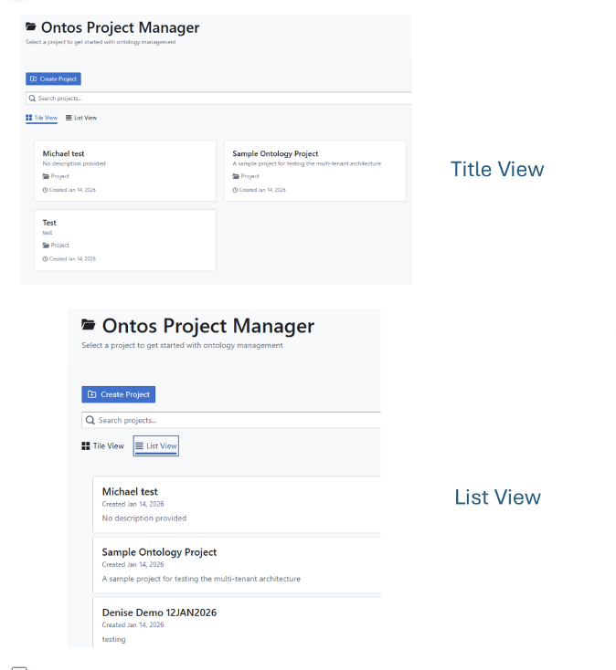
Figure 4.1: Dashboard showing Tile View and List View options

Top Navigation Bar
Element | Function
Select Project | Dropdown to quickly switch between projects
Home Icon | Return to the dashboard
Create Workspace | Create a new workspace (when in a project)
Search Icon | Global search
User Menu | Profile, theme, and sign out options

Project Views
Toggle between two display modes using the buttons above your project list:
Tile View:
- Visual card-based layout
- Shows project name, description, type, and creation date
- Best for browsing and visual overview
- Projects displayed in a grid format
List View:
- Compact row-based layout
- More projects visible at once
- Shows: Name, Created Date, Description
- Best for managing many projects

Searching Projects
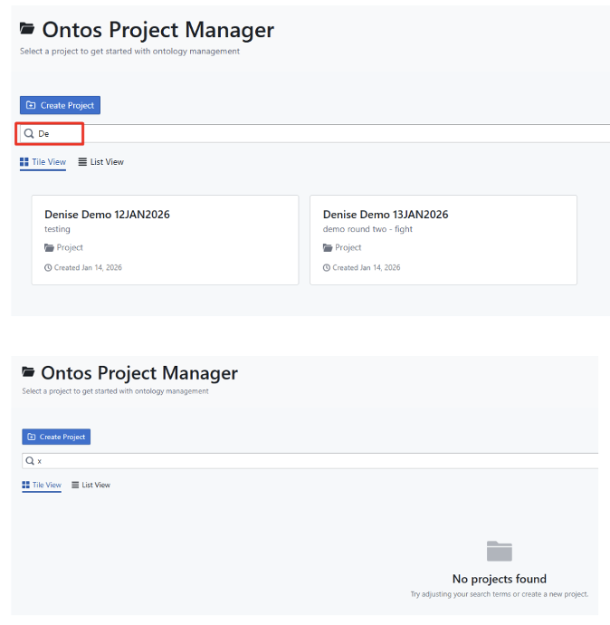
Figure 4.2: Real-time project search filtering
The search bar provides real-time filtering:
- Click in the "Search projects..." field
- Begin typing your search term
- Projects are filtered instantly as you type
- If no matches found, displays "No projects found" with a suggestion to adjust search terms or create a new project
Tip: Search matches against project names. Use specific keywords for faster results.
__________________________________________________

7. Project Management

Creating a New Project
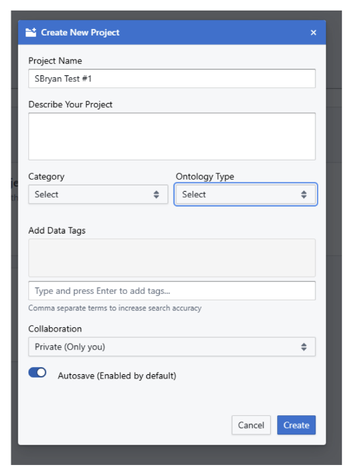
Figure 5.1: Create New Project dialog with all available options
Steps to create a project:
- From the dashboard, click "+ Create Project" (blue button)
- Complete the project creation form:

Field | Required | Description
Project Name | Yes | Unique name for your project
Describe Your Project | No | Brief description of the project's purpose
Category | No | Select from: Government, Financial, Healthcare, Research, Commercial, Personal
Ontology Type | No | Type of ontology - Domain, Upper, Application (dropdown)
Add Data Tags | No | Keywords for searchability (comma-separated, press Enter to add)
Collaboration | No | Privacy setting - Private (Only you), Team, or Public
Autosave | No | Enable automatic saving (enabled by default - blue toggle)
- Click "Create" to create the project
- Click "Cancel" to discard and close the dialog
- The project will appear on your dashboard
Note: Only the Project Name is required. All other fields can be configured later in project settings.

Opening a Project
There are two ways to open a project:
Option 1: From Dashboard Tiles
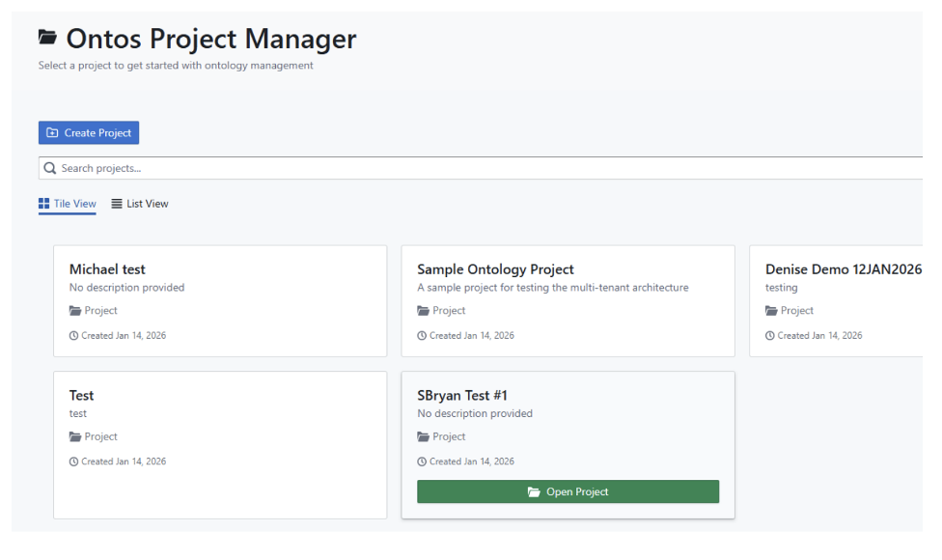
Figure 5.2: Opening a project by clicking the tile and selecting Open Project
- Locate the project on the dashboard
- Click on the project tile (it will be highlighted)
- A green "Open Project" button will appear at the bottom of the tile
- Click "Open Project" to enter the project
Option 2: Using Select Project Dropdown
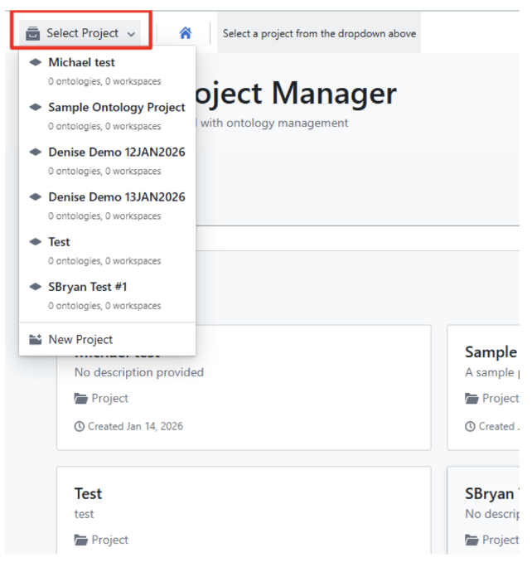
Figure 5.3: Quick project switching using the Select Project dropdown
- Click "Select Project" in the top navigation bar
- A dropdown shows all your projects with:
- Project name
- Number of ontologies (e.g., "0 ontologies")
- Number of workspaces (e.g., "0 workspaces")
- Click on a project to open it immediately
- You can also click "New Project" at the bottom to create a new one
Tip: The Select Project dropdown is available on ALL pages throughout the application, allowing you to quickly switch between projects without returning to the dashboard.

Project Sidebar Menu
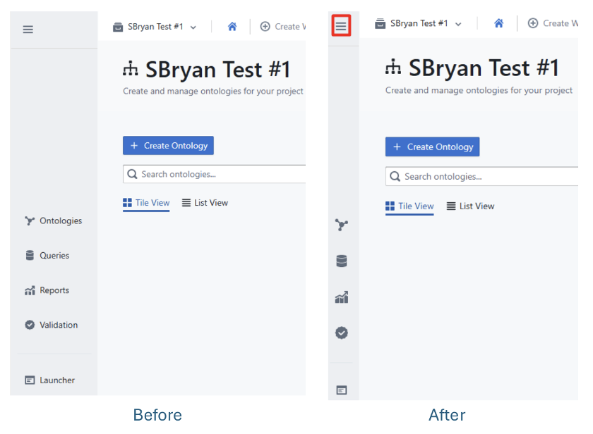
Figure 5.4: Project sidebar menu (expanded and collapsed views)
Once inside a project, a sidebar menu appears on the left with the following options:
Menu Item | Icon | Function
Ontologies | 🔀 | Manage project ontologies
Queries | 📋 | Run SPARQL queries
Reports | 📊 | View generated reports
Validation | ✓ | Quality validation results
Launcher | 📱 | Quick launch tools

Collapsing the Sidebar
To maximize your workspace area:
- Click the hamburger menu (☰) in the top-left corner
- The sidebar collapses to show only icons
- Hover over icons to see tooltips
- Click the hamburger menu again to expand
📸 SCREENSHOT NEEDED: Project settings dialog showing edit options

Deleting a Project
📸 SCREENSHOT NEEDED: Delete project confirmation dialog
- Open the project you want to delete
- Navigate to Project Settings
- Click "Delete Project"
- Confirm the deletion
Warning: Deleting a project removes all associated ontologies, documents, and workspaces. This action cannot be undone.
__________________________________________________

8. Working with Ontologies

Ontology Overview
Within a project, the Ontologies section allows you to create and manage semantic ontologies.
📸 SCREENSHOT NEEDED: Ontology list view showing multiple ontologies with status indicators

Creating an Ontology
- Open your project
- Click "+ Create Ontology" button
- Configure the ontology settings:
Setting | Description
Ontology Name | Descriptive name for the ontology
Base URI | Namespace URI (e.g., http://example.org/ontology#)
Prefix | Short prefix for the namespace
Description | Purpose and scope of the ontology
Foundational Alignment | BFO, CCO, or custom alignment
- Click "Create"
📸 SCREENSHOT NEEDED: Create Ontology dialog with all fields

Ontology Lifecycle
Ontologies progress through defined states:
Status | Description
Draft | Initial development, not finalized
Review | Under review for quality and completeness
Published | Approved and ready for use
Deprecated | No longer recommended for new use
Archived | Preserved for historical reference

Ontology Views
Toggle between viewing modes:
- Tile View: Visual cards showing ontology metadata
- List View: Compact list with sortable columns

Searching Ontologies
Use the "Search ontologies..." field to filter by:
- Ontology name
- Description keywords
- Tags
__________________________________________________

9. Document Processing

Uploading Documents
📸 SCREENSHOT NEEDED: Document upload interface with drag-and-drop zone
- Navigate to your ontology
- Click "Upload Documents" or drag files to the upload area
- Supported formats:
Format | Extension | Description
PDF | .pdf | Portable Document Format
Word | .docx, .doc | Microsoft Word documents
Text | .txt | Plain text files
Markdown | .md | Markdown formatted text
HTML | .html | Web pages
XML | .xml | XML structured data
JSON | .json | JSON data files
CSV | .csv | Comma-separated values
RDF/Turtle | .rdf, .ttl | Existing ontology files
__________________________________________________

Processing Pipeline Details
When you upload a document, it goes through a sophisticated AI-powered pipeline to extract knowledge and build your ontology.

Step-by-Step Pipeline Process

Step 1: Document Ingestion
What it does: Validates and stores the uploaded file
- File type and size validation
- Storage in tenant-isolated location
- Assigns unique document ID for tracking

Step 2: Text Extraction (Parsing)
What it does: Extracts readable text from the document
- PDF text extraction with layout preservation
- DOCX structure parsing
- Image OCR (if applicable)
- Outputs clean, structured text

Step 3: Entity Recognition (NER)
What it does: AI identifies all important "things" mentioned in the text
Example Input:
"Intelligence analysts use radar systems to detect aircraft threats."
AI Processing: Scans text and extracts key entities with classifications
Example Output:
- Intelligence analysts (Person/Role)
- Radar systems (Technology/Equipment)
- Aircraft threats (Concept/Risk)

Step 4: Relationship Extraction
What it does: Identifies how entities connect to each other
Example Output:
- Intelligence analysts use radar systems
- Radar systems detect aircraft threats
- Intelligence analysts analyze aircraft threats

Step 5: Taxonomy Hierarchy Generation
What it does: Organizes entities into a tree-like structure
Example Output:
Military Operations
├── Personnel
│ └── Intelligence Analysts
├── Equipment
│ └── Detection Systems
│ └── Radar Systems
└── Threats
└── Aircraft Threats

Step 6: Foundational Ontology Enrichment
What it does: Maps everything to formal knowledge standards (BFO/CCO)
Example Output:
- Intelligence analysts → BFO: Role, CCO: Person
- Radar systems → BFO: Material Entity, CCO: Artifact
- Aircraft threats → BFO: Dependent Continuant, CCO: Information Entity

Step 7: Quality Validation
What it does: Checks the generated ontology for quality
- Syntax validation (valid OWL/RDF)
- Consistency checking (no logical contradictions)
- BFO/CCO alignment verification
- Naming convention compliance

Step 8: Database Persistence
What it does: Saves the complete taxonomy to the database
- Entities with definitions and provenance
- Relationships with source references
- Full traceability back to source documents
- Formal ontological classifications
📸 SCREENSHOT NEEDED: Processing pipeline progress indicator

Processing Status Indicators
Track document processing status:
Status | Icon | Description
Pending | ⏳ | Queued for processing
Processing | 🔄 | Currently being analyzed
Completed | ✅ | Successfully processed
Failed | ❌ | Error occurred (check logs)
📸 SCREENSHOT NEEDED: Document list with various processing statuses
__________________________________________________

10. Leximap Workflow
Leximap is the Document-to-Taxonomy pipeline that transforms unstructured documents into organized, searchable knowledge hierarchies.

Leximap Workflow Steps
The Leximap workflow consists of 4 main steps:
Step | Widget | Description
1. Document Ingest | document-ingest | Upload and validate files for processing
2. NER Extraction | ner-extraction | Extract entities and relationships from text
3. Taxonomy Review | taxonomy-review | Human-in-the-loop review and refinement
4. Export Results | export | Generate output files in various formats

Using Leximap

Step 1: Document Ingest
- Click "Create New Taxonomy" from the Leximap landing page
- Drag and drop files or click to browse
- Supported formats: PDF, DOCX, TXT, HTML, XML, JSON, CSV
- Click "Upload" to begin processing

Step 2: NER Extraction
The system automatically:
- Extracts text from documents
- Identifies entities (people, places, concepts, technologies)
- Discovers relationships between entities
- Generates confidence scores for each extraction
Progress Tracking: Watch real-time progress as each document is processed

Step 3: Taxonomy Review
This is the human-in-the-loop step where you can:
- Review extracted entities and relationships
- Approve, reject, or modify suggestions
- Add missing entities manually
- Refine the taxonomy hierarchy
- Merge duplicate concepts

Step 4: Export Results
Export your completed taxonomy in multiple formats:
- Turtle (.ttl) - Human-readable RDF format
- OWL/XML (.owl) - For Protege and reasoning tools
- JSON-LD (.jsonld) - For web applications
- CSV (.csv) - For spreadsheet analysis

Leximap Best Practices
- Start with clean documents: Better input quality leads to better extractions
- Process related documents together: Creates more coherent taxonomies
- Use the review step: Human validation improves accuracy
- Export regularly: Save progress in multiple formats
__________________________________________________

11. Ontology Management
Blackkey is the ontology development and management system for creating, editing, and validating professional-grade ontologies.

Workflow Steps
Step | Description
1. Domain Analysis | Analyze the domain and identify key concepts
2. Ontology Proposal | AI-assisted generation of ontology structure
3. Validation & Testing | Human review and logical validation
4. Ontology Publication | Finalize and publish the ontology

Key Features

Visual Ontology Editor
- Drag-and-drop class creation
- Property relationship drawing
- Hierarchy visualization
- Real-time validation feedback

Class Management
- Create classes with labels and definitions
- Define class hierarchies (subClassOf)
- Add annotations and metadata
- Link to foundational ontologies (BFO/CCO)

Property Management
- Object properties (relationships between entities)
- Data properties (attributes with values)
- Domain and range constraints
- Property characteristics (transitive, symmetric, etc.)

Validation Features
- Syntax checking
- Logical consistency verification
- BFO/CCO alignment validation
- Naming convention enforcement

Best Practices
- Start with foundational alignment: Map top-level classes to BFO/CCO
- Use meaningful URIs: Follow naming conventions for maintainability
- Document everything: Add labels and definitions to all elements
- Validate frequently: Run validation checks during development
__________________________________________________

12. Knowledge Graph Visualization

Graph Overview
The knowledge graph visualization provides an interactive view of your ontology's entities and relationships.
📸 SCREENSHOT NEEDED: Full knowledge graph visualization with nodes and edges

Graph Controls
Control | Function
Zoom In/Out | Mouse wheel or +/- buttons
Pan | Click and drag background
Select Node | Click on a node
View Details | Double-click or right-click node
Layout | Change graph layout algorithm

Layout Options
📸 SCREENSHOT NEEDED: Layout selector dropdown showing all options
- Force-Directed: Physics-based natural clustering
- Hierarchical: Tree-like top-down structure
- Circular: Nodes arranged in a circle
- Grid: Organized grid layout
- Radial: Radiating from center

Node Interactions
- Hover: Shows tooltip with entity details
- Click: Selects node and highlights connections
- Double-click: Opens entity detail panel
- Right-click: Context menu with options
📸 SCREENSHOT NEEDED: Node tooltip and context menu

Filtering & Search
📸 SCREENSHOT NEEDED: Graph filter panel
- Filter by entity type
- Filter by relationship type
- Search for specific entities
- Show/hide labels
__________________________________________________
__________________________________________________

13. Reports & Validation

Generating Reports
📸 SCREENSHOT NEEDED: Reports section showing available report types
- Click "Reports" in the sidebar
- Select report type:
- Ontology Summary: Overview statistics
- Quality Assessment: Validation metrics
- Entity Report: List of all entities
- Relationship Report: All relationships
- Provenance Report: Source document tracing
- Click "Generate"
- Report is generated and displayed

Report Export
📸 SCREENSHOT NEEDED: Report export options
Export reports in multiple formats:
- PDF
- HTML
- CSV
- JSON

Validation Checks
The validation system checks for:
Check | Description
Syntax | Valid OWL/RDF syntax
Consistency | No logical contradictions
Completeness | Required elements present
BFO Alignment | Proper foundational ontology mapping
CCO Alignment | Common Core Ontology compliance
Naming Conventions | Consistent naming patterns

Validation Results
📸 SCREENSHOT NEEDED: Validation results panel with issues listed
Results are displayed with severity levels:
Level | Icon | Description
Error | 🔴 | Must be fixed before export
Warning | 🟡 | Should be reviewed
Info | 🟢 | Suggestions for improvement
__________________________________________________

14. Workspaces

What are Workspaces?
Workspaces are customizable views for organizing your ontology work. Each workspace can contain multiple widgets arranged in a grid layout. Workspaces are always linked to a specific project.
📸 SCREENSHOT NEEDED: Workspace with multiple widgets arranged

Creating a Workspace
- Click "+ Create Workspace" in the top navigation
- Enter workspace name
- Select a template or start blank
- Click "Create"
📸 SCREENSHOT NEEDED: Create workspace dialog

Available Widgets
Widget | Function
Graph Viewer | Interactive knowledge graph
Entity List | Browse entities
Triple Editor | Edit semantic triples
Document Viewer | View source documents
Query Panel | Run SPARQL queries
Validation Panel | View validation results
Statistics | Ontology metrics

Customizing Layout
- Drag widgets by their title bar to reposition
- Resize by dragging corners or edges
- Add widgets from the widget menu (+)
- Remove widgets by clicking the X in the title bar
- Maximize a widget to full screen
📸 SCREENSHOT NEEDED: Widget being dragged/resized
__________________________________________________

15. Settings & Preferences

Account Settings
📸 SCREENSHOT NEEDED: Account settings page
Access via the user menu → Settings:
Setting | Description
Profile | Update name, email, avatar
Password | Change your password
Notifications | Email notification preferences
API Keys | Manage API access tokens
Theme | Default light/dark mode

Project Settings
📸 SCREENSHOT NEEDED: Project settings dialog
Within a project, access settings via the gear icon:
Setting | Description
General | Name, description, tags
Collaboration | Team members and permissions
Export | Default export formats
Processing | AI model preferences (LLM vs Manual)
Validation | Enable/disable validation rules
__________________________________________________

16. Troubleshooting

Common Issues
Cannot log in:
- Verify your email address is correct
- Check caps lock is off
- Clear browser cache and cookies
- Try a different browser
- Contact administrator for password reset
Project not loading:
- Refresh the page (F5 or Ctrl+R)
- Check your internet connection
- Try logging out and back in
- Clear browser cache
Document processing stuck:
- Check file size (max 50MB recommended)
- Verify file format is supported
- Check for corrupted files
- View processing logs for errors
- Contact administrator if persistent
Graphs not rendering:
- Enable JavaScript in your browser
- Update your browser to the latest version
- Try reducing the number of displayed nodes
- Check for browser console errors
Slow performance:
- Reduce graph complexity (filter nodes)
- Close unused browser tabs
- Use Chrome for best performance
- Check network connection speed

Getting Help
Support Resources:
- In-app help: Click the ? icon
- Documentation: /docs folder
- Email: support@wti-solutions.com
- GitHub Issues: Report bugs and feature requests

Keyboard Shortcuts
Shortcut | Action
Ctrl + S | Save current work
Ctrl + Z | Undo last action
Ctrl + Y | Redo last action
Ctrl + F | Search in current view
Esc | Close dialogs/modals
? | Show keyboard shortcuts
Ctrl + / | Toggle sidebar
__________________________________________________

Quick Reference Card

Navigation
- Dashboard: Click Home or user menu → Dashboard
- Switch Projects: Use Select Project dropdown (available everywhere)
- Collapse Sidebar: Click hamburger menu

Projects
- Create: Dashboard → + Create Project
- Open: Click tile → Open Project, OR Select Project dropdown
- Search: Use search bar (real-time filtering)

Ontologies
- Create: Inside project → + Create Ontology
- Upload Docs: Drag & drop or click upload
- View Graph: Select ontology → Graph tab

Views
- Tile/List: Toggle buttons above content
- Dark/Light Mode: User menu → Theme toggle
__________________________________________________

Appendix A: Glossary
Term | Definition
Ontology | Formal representation of knowledge as concepts and relationships
Entity | A distinct object, concept, or thing in the domain
Triple | Subject-predicate-object statement (e.g., "Cat is-a Animal")
Class | A category or type of entity
Property | A relationship or attribute
BFO | Basic Formal Ontology - upper-level ontology standard
CCO | Common Core Ontologies - mid-level ontology suite
SPARQL | Query language for RDF data
OWL | Web Ontology Language - W3C standard
RDF | Resource Description Framework - data model
URI | Uniform Resource Identifier - unique identifier
Namespace | Scope for identifiers to avoid conflicts
Leximap | Document-to-Taxonomy pipeline in Ontos Cosmos
Blackkey | Ontology development and management system
NER | Named Entity Recognition - AI extraction of entities from text
Taxonomy | Hierarchical classification system
Tenant | An organization with isolated data in the platform
Workspace | Customizable view containing widgets for ontology work
Widget | Self-contained UI component for specific functionality
Control Plane | Real-time messaging system for widget communication
NATS | Messaging system used for backend service communication
gRPC | High-performance RPC framework for service communication
Provenance | Record of origin and processing history of data
__________________________________________________

Appendix B: File Format Reference

Import Formats
Format | Extensions | Notes
PDF | .pdf | Text-based PDFs recommended
Microsoft Word | .docx, .doc | All versions supported
Plain Text | .txt | UTF-8 encoding recommended
Markdown | .md | GitHub-flavored markdown
HTML | .html, .htm | Extracts text content
XML | .xml | Generic XML parsing
JSON | .json | Structured data
CSV | .csv | Comma-separated values
RDF | .rdf | Import existing ontologies
Turtle | .ttl | Import existing ontologies
OWL | .owl | Import existing ontologies

Export Formats
Format | Extensions | Best For
OWL/XML | .owl | Protege, reasoning tools
Turtle | .ttl | Human-readable, version control
RDF/XML | .rdf | Triple stores, interoperability
JSON-LD | .jsonld | Web applications, APIs
N-Triples | .nt | Large datasets, streaming
GraphML | .graphml | Graph visualization tools
CSV | .csv | Spreadsheet analysis
PNG/SVG | .png, .svg | Graph images
__________________________________________________

Appendix C: Screenshot Capture Checklist
The following screenshots are needed to complete this user guide:
Section | Screenshot Needed | Priority
1. Introduction | Platform overview/landing page | Medium
5. Project Management | Project settings dialog | High
5. Project Management | Delete project confirmation | Medium
6. Ontologies | Ontology list view | High
6. Ontologies | Create Ontology dialog | High
7. Document Processing | Upload interface | High
7. Document Processing | Processing pipeline progress | Medium
7. Document Processing | Document list with statuses | High
8. Leximap | Leximap landing page | High
8. Leximap | NER extraction in progress | Medium
8. Leximap | Taxonomy review interface | High
9. Blackkey | Blackkey visual editor | High
9. Blackkey | Class/property management | Medium
10. Knowledge Graph | Full graph visualization | High
10. Knowledge Graph | Layout selector | Medium
10. Knowledge Graph | Node tooltip/context menu | Medium
10. Knowledge Graph | Filter panel | Medium
11. Queries | SPARQL interface | High
11. Queries | Save query dialog | Low
12. Reports | Reports section | High
12. Reports | Export options | Medium
12. Reports | Validation results | High
13. Workspaces | Workspace with widgets | High
13. Workspaces | Create workspace dialog | Medium
13. Workspaces | Widget resize/drag | Low
14. Settings | Account settings | Medium
14. Settings | Project settings | Medium
__________________________________________________
Ontos Cosmos User Guide - Version 1.1 (Enhanced)
Copyright 2025 WTI Solutions
Last Updated: January 2025

